C>N -rl--lE IVIC>VE

Sturtevant Depot Parking Passes Available!!!

The Village of Sturtevant is now Offering a Monthly Parking Pass as a way to make it easier for regular commuters to enter the lot and to save money. Parking Pass Holders will not have to insert cash or cards into the machine. One simply waves the pass in front of the reader and the gate opens.

The Monthly Parking Pass will be due on the first of the month. The village will not send out payment reminders or invoices. A $20.00 deposit will be required along with the
first payment. This deposit will be forfeited if the pass is lost or the monthly payment is not made by the first of the month. In either case, the card will be de-activated and an additional $20.00 will be required to obtain a new activated card. In order to get the
deposit returned, one must send an activated pass back to the village by mail postmarked by the first of the month or deliver it to the Village Hall before the first of the month.
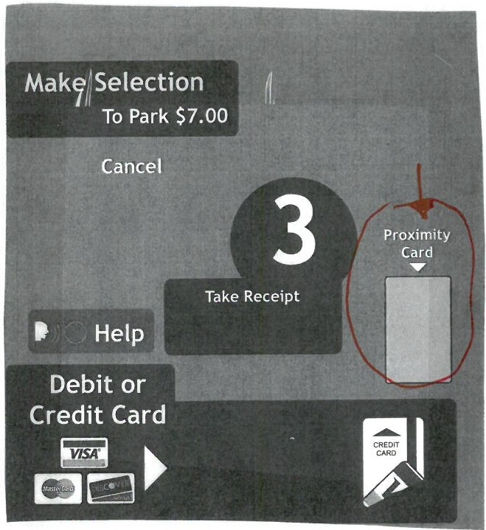
Sales Tax is included in the price.

TO GET A PASS:

Fill out the information below, attach your check (Payable to the Village of Sturtevant) and Mail
to or pay in person during normal business hours:

Village of Sturtevant 2801 89th St.
Sturtevant, WI 53177

Date:

Name Address

Telephone/e-mail address

Deposit $ 20.00

Select One:

Note :
By applying for a monthly parking pass, I understand and agree that if I lose the pass or if I am late in

Monthly Paid
Six Months Yearly
X $80/1 month
----x $300/6 months ----
----
----x $500/Year
making a payment and the card is de-activated, that I will lose the $20.00 deposit. I understand that the Village will not send out monthly reminders, bills
or invoices.

Total Paid --------------- -== = = =

C:\Users\colem\AppData\Local\Microsoft\Windows\Temporary Internet Files\Content.Outlook\VDTGQDPA\Parking letter1,80pass

